Summary Report on
Celebration of World Physiotherapy Day- 2020
School of Physiotherapy celebrates World Physiotherapy Day on 8th September every year to spread awareness about health and wellness among people.
School of Physiotherapy, RK University was Organized various activities such as :-

Event I
Facebook live session with Dr. Dipen Patel, Founder, and CEO of Aalayam Rehab Care. at 10:30 am to 12 pm.
Event II
Facebook live session of Panel Discussion by Rajkot Physiotherapy Association (RPA) from 4 pm to 5 pm.

Event I
Facebook live session with Dr. Dipen Patel, Founder, and CEO of Aalayam Rehab Care. at 10:30 am to 12 pm.
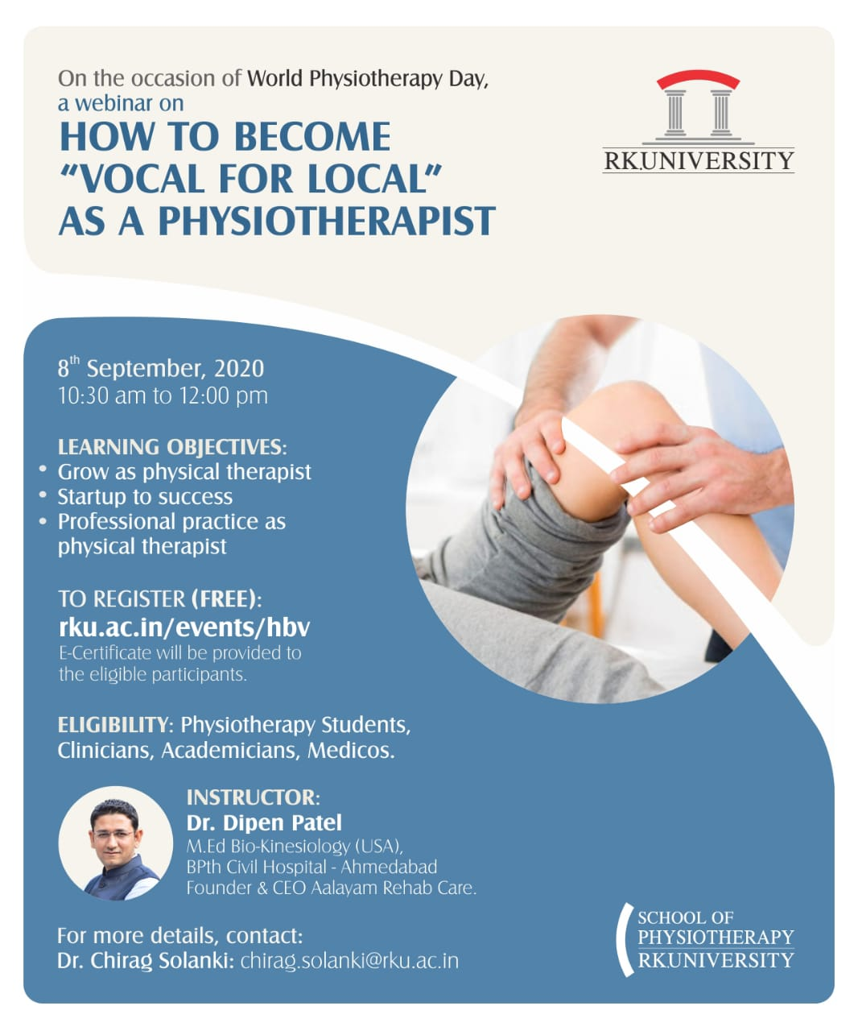
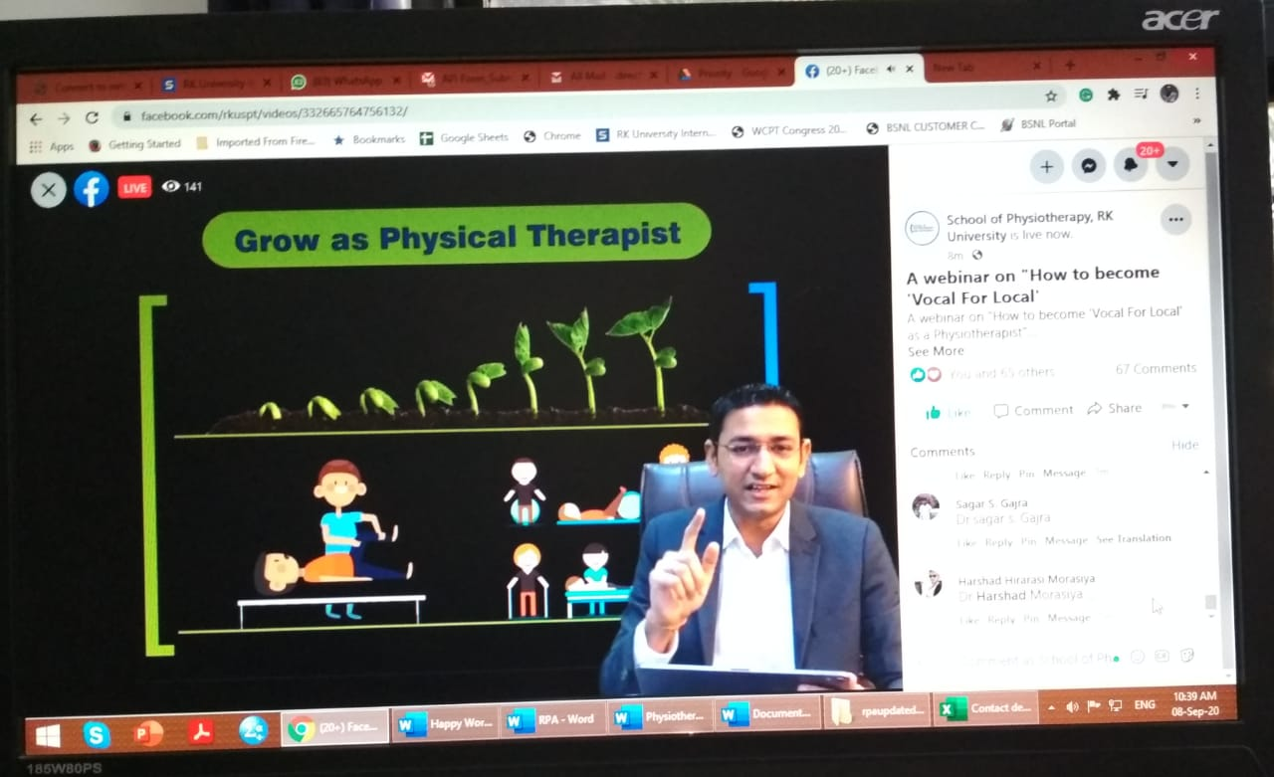
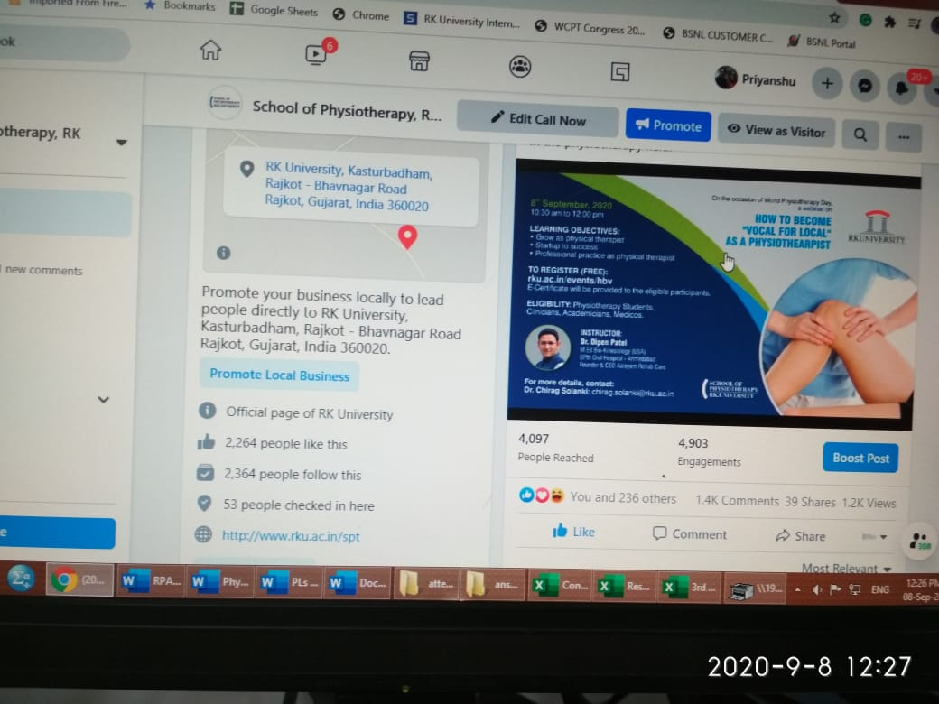

Event II
Facebook live session of Panel Discussion by Rajkot Physiotherapy Association (RPA) from 4 pm to 5 pm.
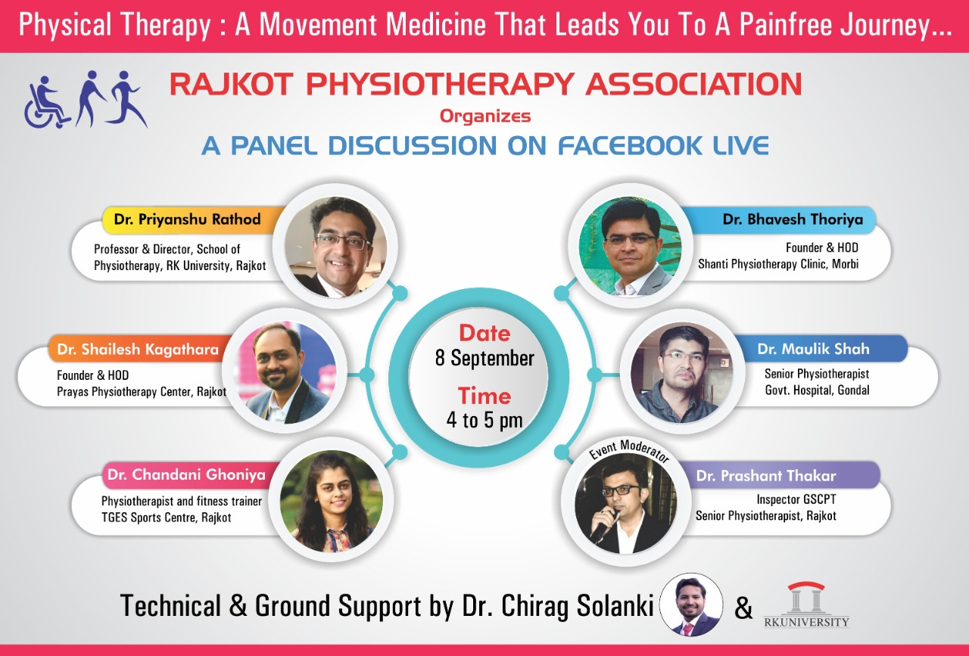

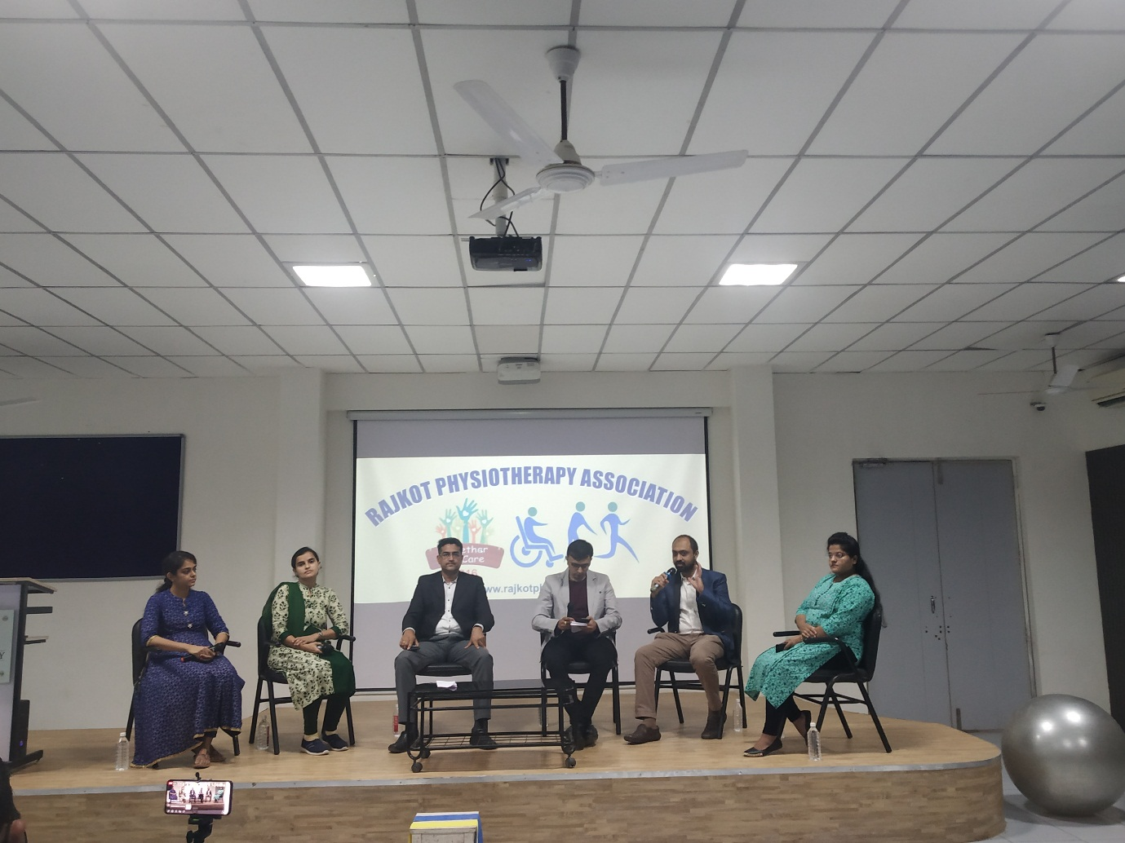

Co-ordinator of the event: Dr.Chirag Solanki

